July 22nd, 2012
Hi
Phew, it's hot here! Yesterday, the temperature was just above 36⁰C for parts of the day, with high humidity as well! The Observatory said this was because very hot weather from a 'high pressure' area in inland China was coming South, aided by a low pressure area (associated with tropical cyclones) below us. And of course, wind blows from high to low pressure areas. Today may be the same. Working in my 'office' is hot even though I have the fan (but not the air-con) on.
I mentioned a couple of weeks or so ago that I was using the 'hibernate' feature on the computer. Well, I have stopped using it. The computer certainly opens faster but then the files, or whatever you leave on the screen when you hibernated sometimes take a very long time to open. A quick check on the Internet found that this is a common problem. So now I use 'Stand By' for short periods (even though the power is not completely switched off as it is with 'hibernate').
The gas bill arrived the other day so now I am getting a better idea of how much it costs to live here. The cost was just $30 per month. However, I am still being overcharged!! as $30 is the minimum monthly charge and I am using slightly less gas than is needed to reach the minimum. Only the water bill now, but that only comes once every four months.
I went to the hospital the other day, the first time for over a year. I had repeatedly changed the date of the appointment as there had been no biopsies at the dermatology clinic until this last time. Although the biopsy done on my nose showed sBCC, the guy said there was no need for surgery now. (Two years ago, the hospital did surgery also on the nose but even then did not remove all of the BCC tissue and that part of the nose is not looking suspicious even now). He also mentioned that because the skin on the nose is so thin, removing any may require major surgery and possible nose reconstruction!
I got an e-mail from the US Government the other day regarding travel to the USA! This involved my ESTA authorisation to travel (ESTA = Electronic System for Travel Authorization). Everybody with passports from visa-free countries (such as NZ) who want to travel to the US have to get pre-approval / security clearance before being allowed to travel there. This is a lot of trouble as it can take up to about three weeks for approval, though in my case it only takes a few seconds once the last 'click' was made. The authorisation is valid for two years and my current one expires next month (while in the US actually), and the e-mail was to remind me of this. I probably did not need to do anything as my travel begins before the expiry, but to be on the safe side, I renewed it. Now, however, it costs USD14 whereas it used to be free!
Leonie. I got the photos you sent. Thanks. I particularly liked the black-and-white pics. Risky using facebook though, as I quite often get one or two of them which I immediately delete as I am not interested in them and also because one has to log in to facebook. But, I did click on your mail and I saw there were photos and that the file opened without having to log on.
I have a lot of work to do at the moment after the occasional day off in the past two weeks with nothing to do. A lot of the time will be spent on proof reading and preparing teachers' guides.
The Super Rugby tournament has reached the semi-final stage. The tornament now 15 teams remember, five from each country. But they now have play-offs among the top eight teams. The quarter-finals were this weekend, the semis next. In one semi-final the Crusaders play another NZ team (the Chiefs). The other semi-final is between to SA teams. No Australian team got his far.
The temperature of the swimming pool water here is now up to 31⁰C. I note in the letter below (from 2006) that the hotel pool water was up to 34⁰C at this time.
That seems to be it for now.
Cheers

July 23rd, 2006
Hi
Well. July has almost gone now!
Last weekend, we had some heavy rain. In fact, it was so heavy that it set a HK record of about 115 cm (4.6”) for the amount of rain falling in a one-hour period. That cooled the pool water down to 29⁰C on Monday but it gradually crept up again so that by Friday, it was 34⁰C.
I had a follow-up hospital appointment on Wednesday. All seems OK with the skin cancer excisions. However, the one-suspected cancer spot on the lower calf that they knew about last time but did not remove, they now want to do so. Therefore, I have to go back this coming Thursday morning for the operation. It will just involve a local anaesthetic. Then, last Thursday I went to the dermatologist again for the bimonthly appointment. Mainly involved just reporting on what the surgeons had done in the hospital.
Because I will not be able to swim again for a while after the operation, I decided to do all swimming until then and leave the gym until later. Therefore, this past week I swam for four days doing a total of 7.2 km. As I now go later in the day to avoid the higher UV radiation from the Sun during the day, and also because it is summer with more people in the pool, I did all the swimming at the deep end. I like swimming there except that the lengths are shorter and I sometimes lose count of the laps. So, I decided to use a sandal as a lap counter, putting it at the edge of the pool, turning it around a quarter every 10 laps (I can usually count to 10 all right). However, on one of the three days I used it, some people sat on the edge of the pool and mucked around with it!
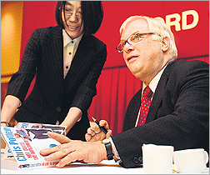
Chris Patten in back in HK again, the second time this year still flogging his previous book as well as another one. This time, however, he did not eat any daan tarts; in fact he was offered a plateful somewhere and politely rejected it. This is because he is now rather fat (see photo) and his wife (who also came) has given strict instructions that he lose weight and not eat them.
HK is thinking of introducing GST and meeting almost universal opposition to it. Patten was asked to comment on it, and he too did not favour the idea. This raised a few heckles in the government, especially from the Financial Secretary whose idea it is, who fired back! Patten was also asked about democracy and said that HK has been ready for full democracy again irritating those who say HK is not ready. Donald Tsang was in Singapore recently and praised the island’s democratic system saying that it could serve as a model for HK. That too did not go over too well either.
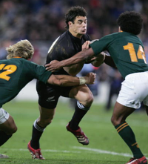
The third match of the tri-nations was yesterday between NZ and SA in Wellington. The ABs won 35-17 with Daniel Carter (pictured) scoring 25 of the 35 points. Both teams scored two tries each. The NZ coach had changed more than half of the team from the previous game. He is trying to build up a big pool of experienced players before next year’s Rugby World Cup (to be held in France). I was reading on the Planet Rugby website of another match between NZ and SA held in Wellington 50 years ago. That was the time when I first became aware of international Rugby and test matches. SA won that test 8- 3 (but lost the 4-test series), scoring two tries (in those days a try was worth only 3 points). However, in those days, there were many fewer test matches and, especially for SA and NZ, were just a notch below a declaration of war, with both countries selecting there best teams. Not like yesterday, when NZ essentially had a ‘second 15’ and were using the test as preparation for the cup next year!
There will not be any problem with space soon with Netscape. Next month, they are to increase it to 2 Gb, which is the same as Gmail.
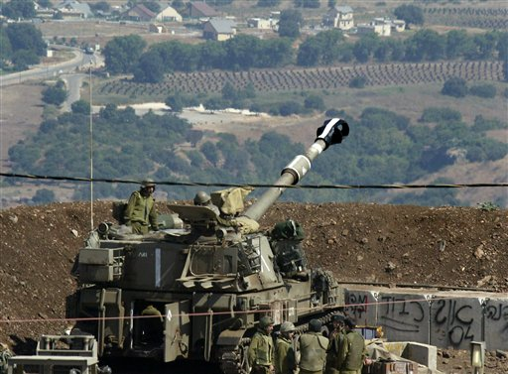

Gavin, I will respond here to your comments on the latest Middle East conflict. I think that the main culprit is Hezbollah, which is definitely a terrorist organisation. Their ideology means that they must attack Israel. I also believe that Israel is allowed to defend itself and to deal with Hezbollah. However, I am very sad for the people of the Lebanon. I think that the people in southern Lebanon are not Lebanese but mainly Palestinians Shi’ites who flooded into the Lebanon after being kicked out of Jordan in 1970 and are ethnically distinct from the Lebanese. The Lebanon is still near the top of favourite country list. I enjoyed my stay there in 1968, which was before the Palestinian refugees flooded in and before the 1975-1990 civil war. So, if Hezbollah is ‘neutralised’ it may be a good thing. However, they or others are likely to pop up somewhere else. Nevertheless, for me, Israel should restrict its activities to Hezbollah. At least, they are dropping pamphlets telling civilians to get out.
That seems to be it for now.
Cheers

